**CALL CENTER ANALYSIS**

# Abstract: -

This project aims to develop a data warehouse solution for call center analytics and customer service improvement using ETL tools to extract data, data warehousing for data storage, and Power BI for data visualization and analysis.

# Introduction: -

Developing a data warehouse for call center analytics and customer service improvement involves gathering and integrating data from various sources into a central repository, transforming it into a structured format, and using visualization tools like Power BI to analyze and gain insights from the data.

ETL (Extract, Transform, Load) is a common process used to integrate data from disparate sources into a data warehouse. Data is extracted from various sources, transformed to meet specific business requirements, and loaded into the data warehouse for analysis. The data warehouse acts as a central repository of integrated data that can be used for reporting and analysis.

Data warehousing is the process of designing and building a data warehouse. It involves defining the data sources, identifying the key business metrics, designing the data model, and implementing the ETL process to load data into the warehouse. The data warehouse should be optimized for performance, scalability, and ease of use.

Visualization tools like Power BI enable users to create interactive dashboards, reports, and visualizations from the data in the data warehouse. Power BI provides a range of data visualization options, including charts, graphs, maps, and tables, which can be used to identify trends, patterns, and insights.

By developing a data warehouse for call center analytics and customer service improvement, organizations can gain a better understanding of their customers' needs and preferences, identify areas for improvement, and make data-driven decisions to improve customer satisfaction and retention.

# Literature Survey

|  |  |  |  |  |  |
| --- | --- | --- | --- | --- | --- |
| Ref No | Title of the Paper | Author | Published Year | Method | Data Set |
| 1. | Analysis of Call-Center Operation Data Using Role Hierarchy Miner. | Sompong Wongvigran | 2015 | Machine Learning Algorithm (Hierarchy Miner) | Call-Center event log data. |
| 2. | Intelligent decision making and planning for call center. | Islamabad | 2019 | Customer Service Reprehensive (CSR) and Machine Learning Algorithm (k-Means Clustering) | Call Center customer service data. |
| 3. | Call Center performance Evaluate Using Big Data Analysis. | Betul Karakus | 2016 | Machine Learning Algorithm (Cosine and n-gram) and Hadoop | Call-Center data. |
| 4. | Analysis of Handover of Work in Call Center using Social Network Process Mining Technique. | Patcharin Panpanich | 2015 | Handover of Work (Social Network Miner) | Call-Center event log data. |
| 5. | Machine Learning-based Silence Detection in Call Center Telephone Conversation | Leonardo O. Iheme | 2019 | Machine Learning Algorithm (Clustering) and Deep Learning-Based applied to VAD. | Call-Center data. |

# Materials and Methods: -

### Data Source: -

[call center dataset | Kaggle](https://www.kaggle.com/datasets/ashishpandey5210/call-center-dataset)

### ETL Processing: -

ETL processes involve extracting data from various sources, transforming it into a common format, and loading it into the data warehouse. This step can be performed using ETL tools like SSMS and the data can be extracted by using SSIS

### Data Warehousing: -

Once the data is transformed and loaded, it needs to be organized into a structured format that is optimized for reporting and analysis. This is done using data warehousing tools like Microsoft SQL Server Management studio (SSMS)

### Data Visualization: -

Data visualization tools like Microsoft Power BI, Tableau, or QlikView can be used to create interactive dashboards and reports that provide insights into call center performance and customer satisfaction. These tools allow users to easily slice and dice data, identify trends and patterns, and generate actionable insights

## 3.1 Data Set Details: -

The dataset consists of call center data with following variables

|  |  |
| --- | --- |
| Variable | Description |
| Call Id | Unique id |
| Date | Date of call received |
| Agent | Call received Agent |
| Department | Department of Agent |
| Answered | Call Answered or Not |
| Resolved | Call Resolved or Not |
| Speed of Answer | Speed of answering call |
| Avg Talk Duration | Call Duration |
| Satisfaction rating | Rating given by customers |

Table: - Dataset

## 3.2 Proposed System: -

# Implementation and Results: -

### Data Pre-Processing: -

Data pre-processing is an important step in the data mining process. It refers to the cleaning, transforming, and integrating of data in order to make it ready for analysis

Replacing null data using python

import pandas as pd

data=pd.read_excel("C://Users//venka//Downloads//Call Center Dataset 1.xlsx")

data.head()

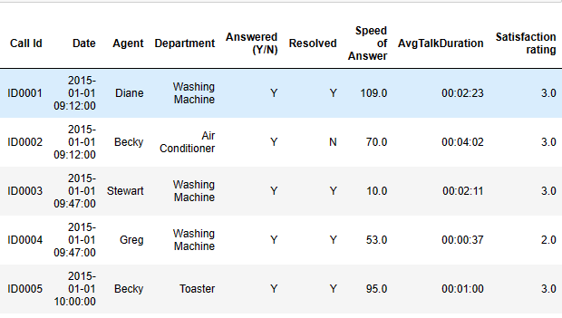

data.info()

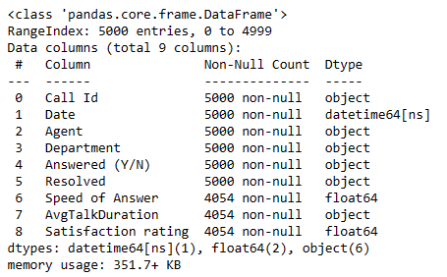

data.isnull().sum()

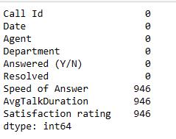

data['Speed of Answer']=data['Speed of Answer'].fillna(data['Speed of Answer'].median())

data['Satisfaction rating']=data['Satisfaction rating'].fillna(data['Satisfaction rating'].median())

data['AvgTalkDuration']=data['AvgTalkDuration'].fillna(data['AvgTalkDuration'].mode()[0])

data.isnull().sum()

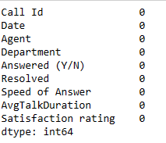

data.to_excel("C://Users//venka//Downloads//Call Center Dataset.xlsx")

## Loading data into SSMS USING SSIS: -

Loading the excel data into SSMS using SSIS of visual studio

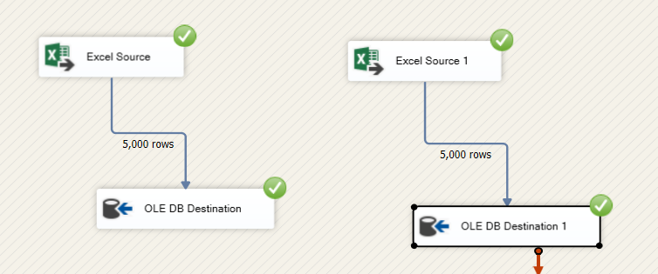

## ETL process in SSMS: -

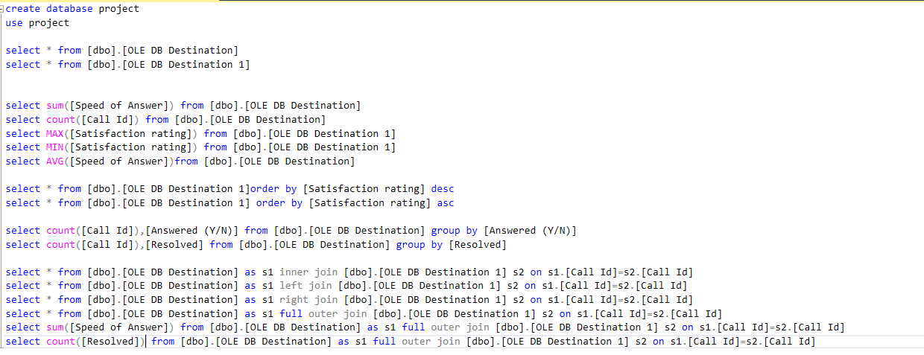

## Merging 2 tables in SSIS: -

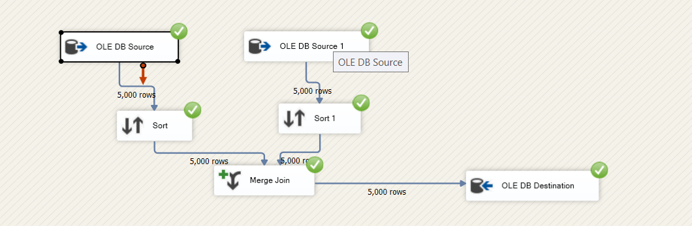

## Visualization in Power Bi: -

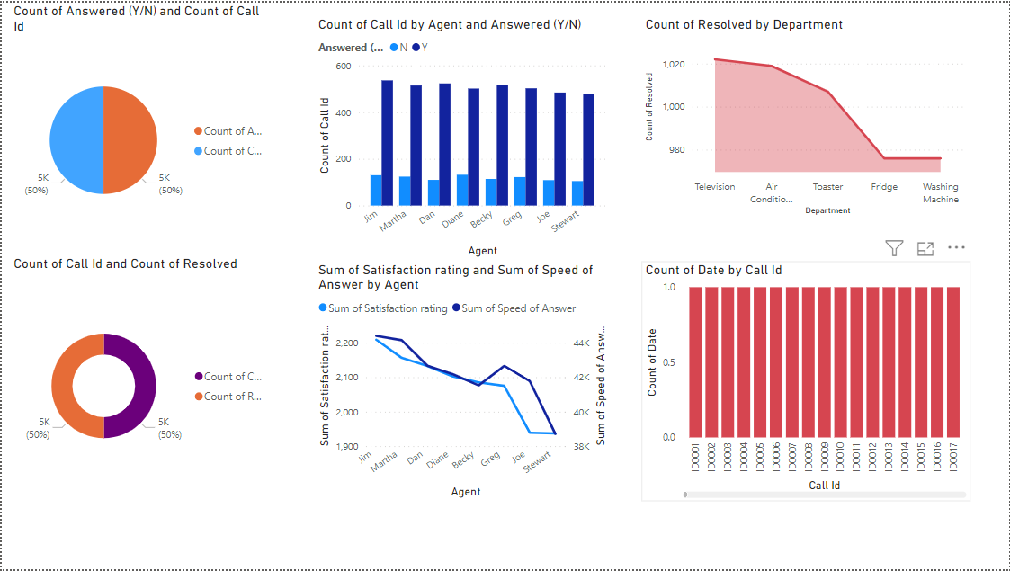

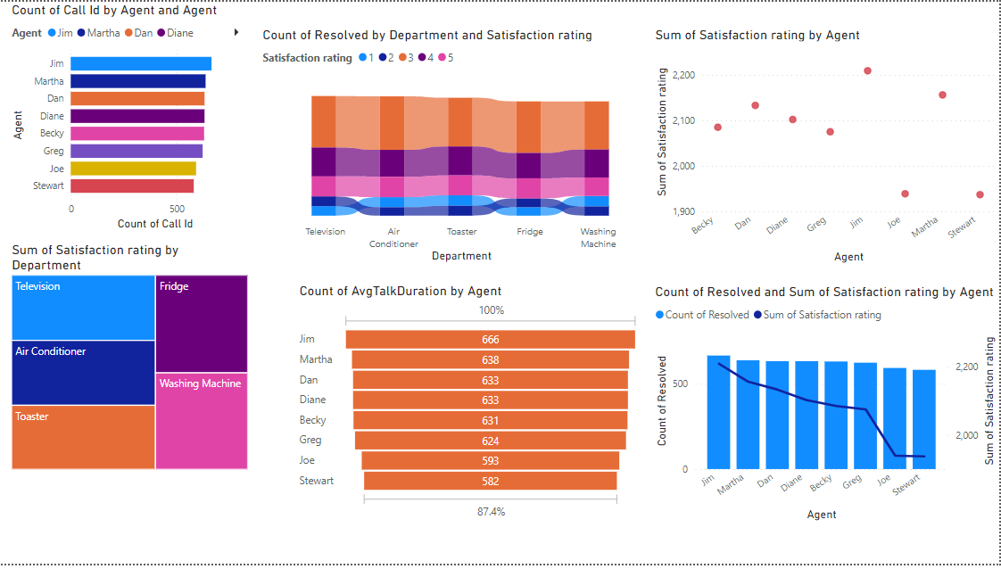

# Conclusion and Future works: -

The key benefits of using a data warehouse for call center analytics include improved customer service, increased operational efficiency, better resource management, and enhanced decision-making capabilities. By analysing data from different sources, such as customer feedback, call recordings, and agent performance metrics, organizations can identify areas of improvement and implement targeted solutions.

To further improve the effectiveness of a data warehouse for call center analytics, organizations can explore additional tools and techniques. For example, machine learning algorithms can be used to identify patterns and predict customer behaviour, while natural language processing can be used to analyze customer feedback and sentiment.

Another important consideration is data security and privacy. Organizations should implement appropriate measures to ensure that sensitive customer data is protected and that data privacy regulations are adhered to.

Developing a data warehouse for call center analytics and customer service improvement is an ongoing process that requires careful planning, implementation, and maintenance. By using the right tools and techniques, organizations can gain valuable insights and improve their call center operations, leading to better customer experiences and business outcomes.

# References

[1] Author Sompong Wongvigram “Analysis of Call-Center Operation Data Using Role Hierarchy Miner” published year 2015, method Machine Learning Algorithm (Hierarchy Miner).

[2] Author Islamabad “Intelligent decision making and planning for call center” published year 2019, method Customer Service Reprehensive (CSR) and Machine Learning Algorithm (k-Means Clustering).

[3] Author Betul Karakus “Call Center performance Evaluate Using Big Data Analysis” published year 2016, method Machine Learning Algorithm (Cosine and n-gram) and Hadoop.

[4] Author Patcharin Panpanich “Analysis of Handover of Work in Call Center using Social Network Process Mining Technique” published year 2015, method Handover of Work (Social Network Miner).

[5] Author Leonardo O. Iheme “Machine Learning-based Silence Detection in Call Center Telephone Conversation” published year 2019, method Machine Learning Algorithm (Clustering) and Deep Learning-Based applied to VAD.